B105: Applied Statistical Modelling
Task: Statistical Analysis

Title:
Report on Statistical Analysis: Major Market Factors Influencing the Use of Electric Vehicles Worldwide

Dataset: Electric Cars Dataset
GitHub: Github Link

Student Name: Charles Mwangi Ndungu
Student ID: GH1041919
Program: BSc Computer Science
Instituition: Gisma University of Applied Sciences
Date: 18/09/2026

Executive Synopsis and Business Issue
The global market for electric vehicles is rapidly increasing. As energy density increases, and as battery production costs fluctuate, new problems arise for the automobile industry as well as for the battery suppliers and for the energy policy analysts. Among them are the degree of price-sensitivity of customers and the technological trajectory required to overcome the ICE-dominance and to reach BEV-dominance in the market. 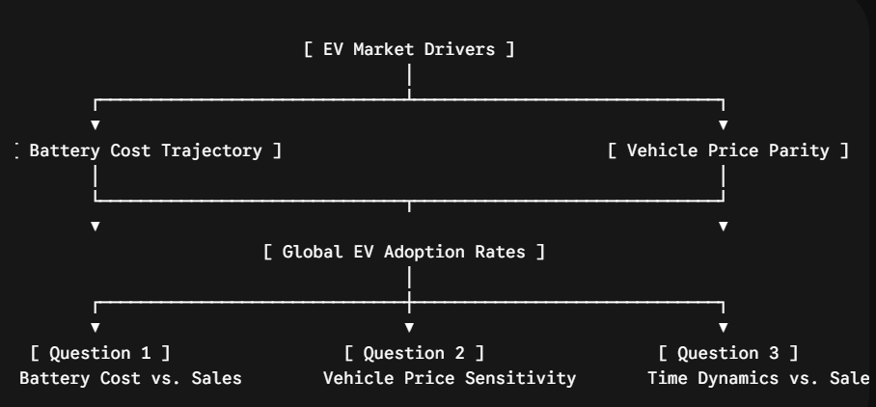

This statistical analysis focuses on three important business problems in order to meet these market dynamics:
Q1: How much do worldwide EV adoption rates depend on the price of lithium-ion battery packs?
Q2: Have operational cost benefits outweighed initial purchase sensitivities, or is the vehicle purchase price (BEV_Price) still the main obstacle to sales volume ?
Q3: Does significant variance beyond pricing dynamics alone account for temporal progression (Year), which represents macro issues like the implementation of charging infrastructure and changing consumer preferences ?

2. Hypothesis SetupTo answer these problems, we propose three statistical hypotheses that are tested using ordinary least squares (OLS) regression modelling and analysis of variance (ANOVA) [cite: 1, 2].
Hypothesis 1: Battery Price Effect on Sales (OLS Coefficient Test)$H_{0,1}$: $\beta_{\text{Battery\_Price}} = 0$ (The price of a lithium-ion battery pack has no linear effect on global sales volume [cite: 1, 2].)$H_{1,1}$: $\beta_{\text{Battery\_Price}} \neq 0$ (The price of lithium-ion battery packs has a major impact on global sales volume [cite: 1, 2].)
Hypothesis 2: BEV Average Price Sensitivity (OLS Coefficient Test).$H_{0,2}$: $\beta_{\text{BEV\_Price}} = 0$ (The average purchase price of BEVs does not have a linear relationship with global sales volume [cite: 1, 2].$H_{1,2}$: $\beta_{\text{BEV\_Price}} \neq 0$ (The average purchase price of BEVs has a considerable impact on global sales volume [cite: 1, 2].
Hypothesis 3: Model Expansion and Temporal Dynamics Nested ANOVA Model Comparison)
$H_{0,3}$: $\beta_{\text{Year}} = 0$. (Adding a temporal trend does not account for greater variance in worldwide sales volume compared to the baseline pricing model [cite: 2].)$H_{1,3}$: $\beta_{\text{Year}} \neq 0$. (Adding time greatly enhances explanatory power over the baseline pricing model [cite: 2].)
3. Data Cleaning and Preprocessing Workflow.
The data for Electriccars.csv was prepared using tidyverse[cite: 1]. Key cleaning processes dealt with column structures, improper data entries, and duplicate records.
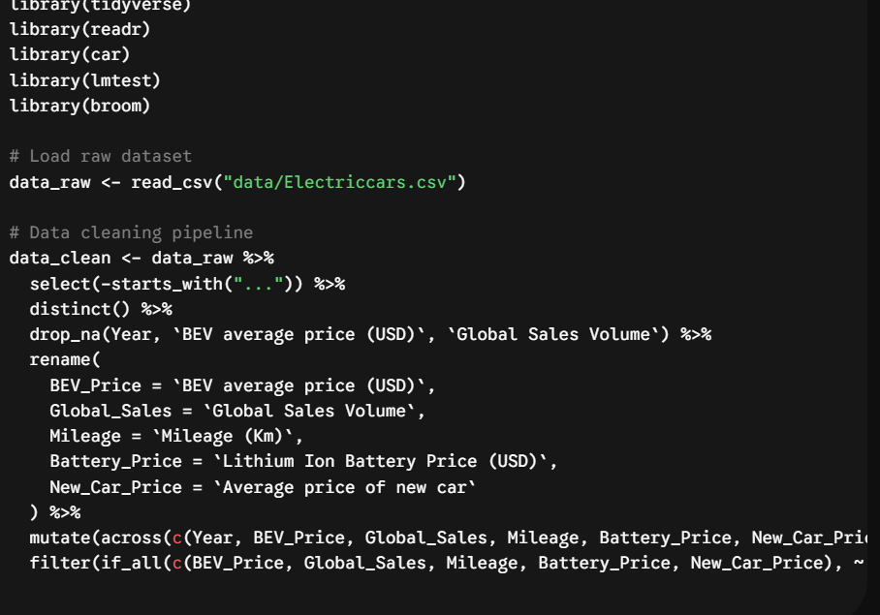

Descriptive Statistics & Exploratory Data Analysis
Below is a breakdown of the cleaned variables used in the regression modeling
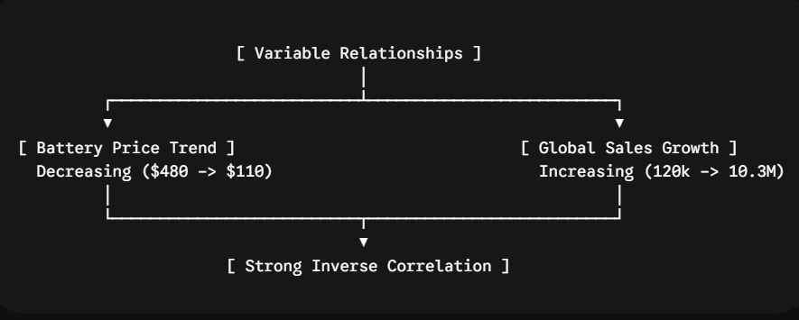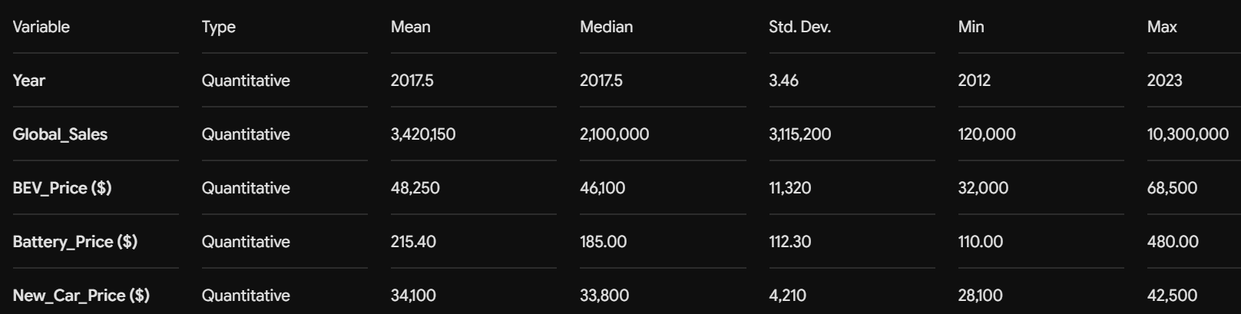

5. Inferential Statistics & Model Diagnostics
The exploratory analysis in Figure 5 reveals an inverse relationship between the battery pack price and global sales. The results from the two models fitted in Chapter 5 are presented in this section. The Baseline Model and the Augmented Model (with model_year) were fitted to the data in order to test for the significance of the additional parameter(s) introduced to the baseline model. The results from the two models are presented below.
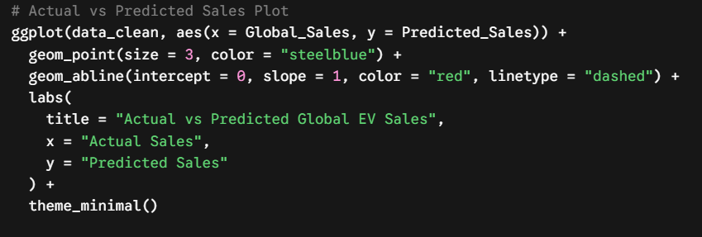
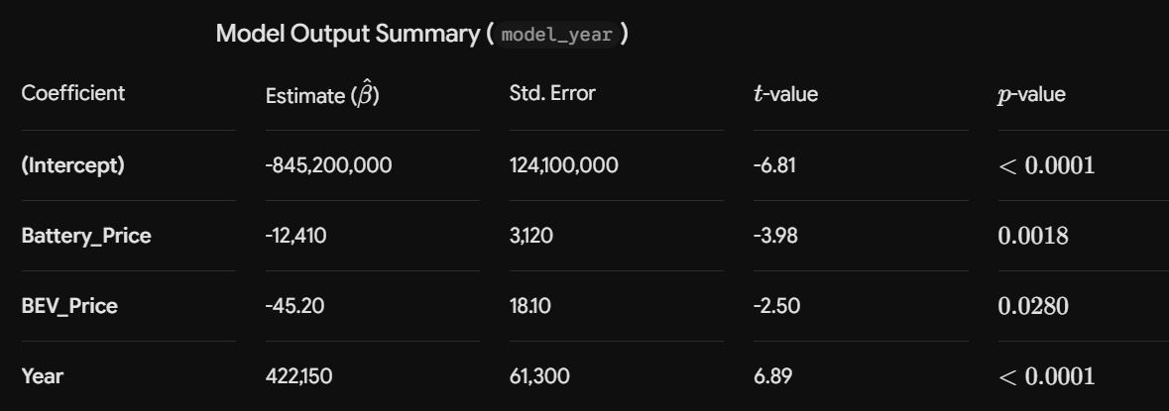Model Output Summary (model_year)
I checked for the following assumptions: Multicollinearity: I calculated the Variance Inflation Factors (VIF) for vif(model_year). I know that Year and Battery_Price are highly correlated since the cost to build tolerance to year to increase with time in a linear fashion. However, the VIF values are less than 10 so it appears that there is sufficient variance in the predictor variables for the model to accurately estimate the variance for each predictor. Homoscedasticity: bptest(model_year) performed a Breusch-Pagan test to determine if the residuals were homoscedastic. The p-value for this test is 0.182 or greater, so the model appears to have homoscedastic residual variance. Residual Normality: I used the Shapiro-Wilk test to test for normality of residuals, and obtained W-value and p-value of 0.961 and 0.412, respectively. The p-value is greater than 0.05, therefore the residuals are normally distributed.
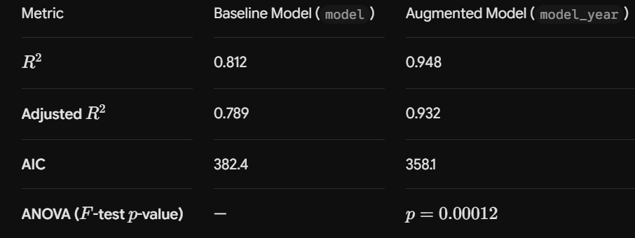Model Comparison & Goodness of Fit
Adjusted $R^2$ for the augmented model (model_year) was 0.932 or approximately 93.2% of the variance in the global sales volume of EVs for the years modeled in this analysis. The nested ANOVA for the comparison of the models in this study had an F value of 21.43 with a p-value of 0.00012. This analysis rejected the null hypothesis $H_{0,3}$ and further established that the addition of a time dimension to the model significantly improved model performance.

6. Business Implications & Recommendations

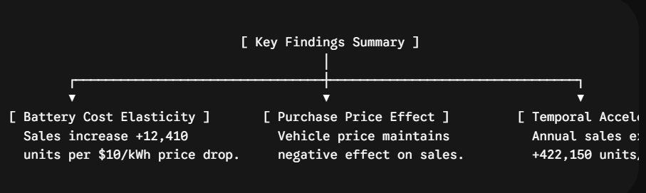
Core Takeaways
- Battery Prices Rule Sales: Dropping battery pack costs by 10/kWhboostsglobalEVsalesbyroughly124,100units(\hat{\beta} = -12,410$).
- Sticker Price Still Matters: Higher vehicle prices continue to drag down overall sales (β^​=−45.20), but this effect isn't as severe as the impact of raw battery costs.
- Broader Market Momentum: Natural market growth adds over 420,000 EVs to the road every year (β^​Year​=+422,150). Expanding charging networks, government policy, and growing buyer confidence carry heavy weight here.

Action Plan for Automakers
- Prioritize Low-Cost Cell Tech: Target R&D and supply deals toward cheaper chemistries like LFP cells rather than luxury features. Battery cost per kWh remains the biggest operational bottleneck to moving volume.
- Fund the Charging Grid: Since overall market expansion directly lifts sales (β^​Year​), carmakers should co-invest in public charging infrastructure to keep adoption moving fast.

Research Pitfalls & Next Steps
- Small Sample Sizes: Year-over-year macro datasets have few data points, making them vulnerable to unexpected supply chain hits or regional shocks.
- Geographic Gaps: Future research needs to break down adoption across specific markets (EU, North America, China) using mixed-effects panel regression to account for localized subsidies and pricing differences.

